 | CLG An Clochan Liath  Individual Fitness Report  3rd January 2026
Aaron Ward
Weight: 86.6kg | Body Fat: 12.0% (Good)
Test | Your Result | Squad Avg | Status
KTW - Right (cm) | 12.0 | 11.6 | Above
KTW - Left (cm) | 12.0 | 11.3 | Above
Overhead Squat (1-3) | 2 | 2.3 | Below
CMJ (cm) | 37.9 | 38.2 | Below
Squat Jump (cm) | 32.7 | 33.4 | Below
Press Ups (60s) | 51 | 45 | Above
Pull Ups (60s) | 14 | 13 | Above
0-10m Sprint (s) | 1.882 | 1.864 | Below
Bronco Test | 4:52 | 5:23 | Above

EUR (Eccentric Utilization Ratio): 1.16 (Optimal) | Squad Avg: 1.15
MAS (100%): 4.11 m/s | MAS (120%): 4.93 m/s | Squad Avg: 3.74 m/s
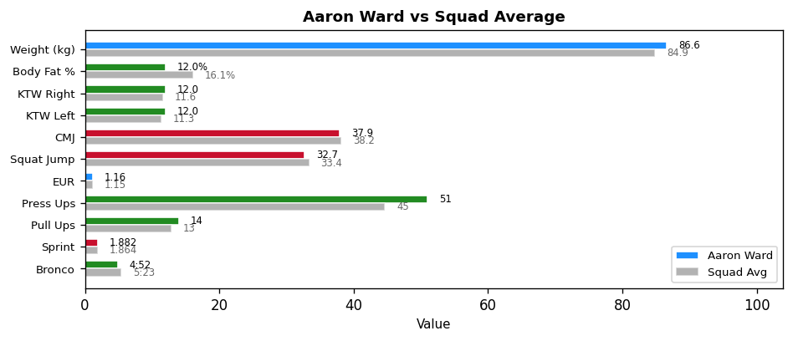

Key Focus Areas: All tests within target - maintain current programme
Next Testing: 28th February 2026

CLG An Clochan Liath
Individual Fitness Report
3rd January 2026
Dylan Sweeney
Weight: 68.6kg | Body Fat: 12.8% (Good)
Test | Your Result | Squad Avg | Status
KTW - Right (cm) | 12.0 | 11.6 | Above
KTW - Left (cm) | 12.0 | 11.3 | Above
Overhead Squat (1-3) | 3 | 2.3 | Above
CMJ (cm) | 43.4 | 38.2 | Above
Squat Jump (cm) | 34.4 | 33.4 | Above
Press Ups (60s) | 52 | 45 | Above
Pull Ups (60s) | 21 | 13 | Above
0-10m Sprint (s) | 1.758 | 1.864 | Above
Bronco Test | 5:03 | 5:23 | Above

EUR (Eccentric Utilization Ratio): 1.26 (High) | Squad Avg: 1.15
MAS (100%): 3.96 m/s | MAS (120%): 4.75 m/s | Squad Avg: 3.74 m/s
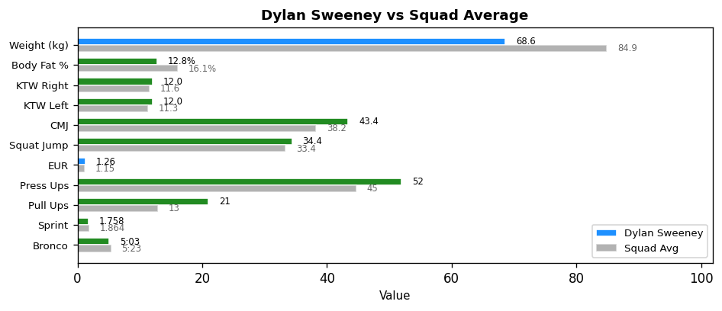

Key Focus Areas: Maintain elasticity, build strength (High EUR)
Next Testing: 28th February 2026

CLG An Clochan Liath
Individual Fitness Report
3rd January 2026
Karl Magee
Weight: 83.0kg | Body Fat: 16.0% (Acceptable)
Test | Your Result | Squad Avg | Status
KTW - Right (cm) | 10.5 | 11.6 | Below
KTW - Left (cm) | 10.5 | 11.3 | Below
Overhead Squat (1-3) | 1 | 2.3 | Below
CMJ (cm) | 41.3 | 38.2 | Above
Squat Jump (cm) | 38.1 | 33.4 | Above
Press Ups (60s) | 45 | 45 | Above
Pull Ups (60s) | 19 | 13 | Above
0-10m Sprint (s) | 1.846 | 1.864 | Above
Bronco Test | 5:08 | 5:23 | Above

EUR (Eccentric Utilization Ratio): 1.08 (Low) | Squad Avg: 1.15
MAS (100%): 3.90 m/s | MAS (120%): 4.68 m/s | Squad Avg: 3.74 m/s
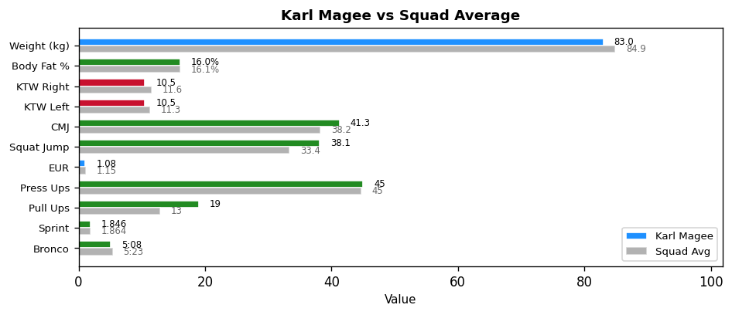

Key Focus Areas: Movement quality | Eccentric lifts & plyometrics (Low EUR)
Next Testing: 28th February 2026

CLG An Clochan Liath
Individual Fitness Report
3rd January 2026
Darren Curran
Weight: 88.0kg | Body Fat: 13.0% (Good)
Test | Your Result | Squad Avg | Status
KTW - Right (cm) | 12.0 | 11.6 | Above
KTW - Left (cm) | 12.0 | 11.3 | Above
Overhead Squat (1-3) | 2 | 2.3 | Below
CMJ (cm) | 46.8 | 38.2 | Above
Squat Jump (cm) | 40.0 | 33.4 | Above
Press Ups (60s) | 65 | 45 | Above
Pull Ups (60s) | 23 | 13 | Above
0-10m Sprint (s) | 1.930 | 1.864 | Below
Bronco Test | 5:05 | 5:23 | Above

EUR (Eccentric Utilization Ratio): 1.17 (Optimal) | Squad Avg: 1.15
MAS (100%): 3.93 m/s | MAS (120%): 4.72 m/s | Squad Avg: 3.74 m/s
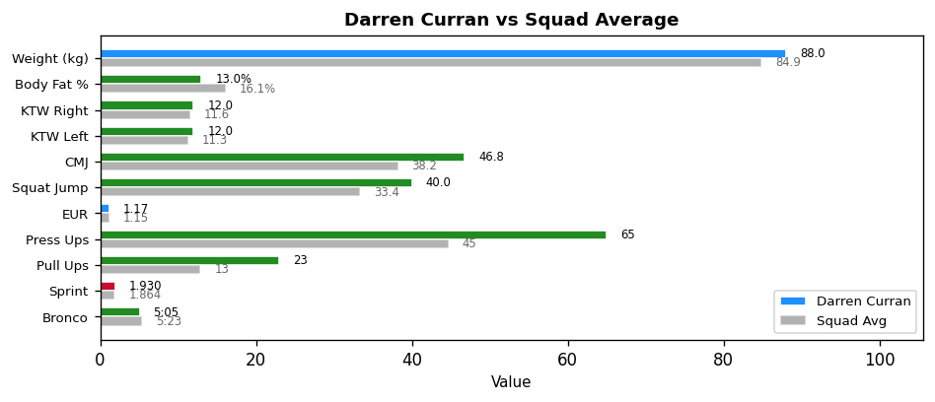

Key Focus Areas: All tests within target - maintain current programme
Next Testing: 28th February 2026

CLG An Clochan Liath
Individual Fitness Report
3rd January 2026
Damien Mcgowan
Weight: 89.0kg | Body Fat: 14.0% (Good)
Test | Your Result | Squad Avg | Status
KTW - Right (cm) | 12.0 | 11.6 | Above
KTW - Left (cm) | 10.0 | 11.3 | Below
Overhead Squat (1-3) | 2 | 2.3 | Below
CMJ (cm) | 39.2 | 38.2 | Above
Squat Jump (cm) | 38.7 | 33.4 | Above
Press Ups (60s) | 33 | 45 | Below
Pull Ups (60s) | 10 | 13 | Below
0-10m Sprint (s) | 1.856 | 1.864 | Above
Bronco Test | 5:10 | 5:23 | Above

EUR (Eccentric Utilization Ratio): 1.01 (Low) | Squad Avg: 1.15
MAS (100%): 3.87 m/s | MAS (120%): 4.65 m/s | Squad Avg: 3.74 m/s
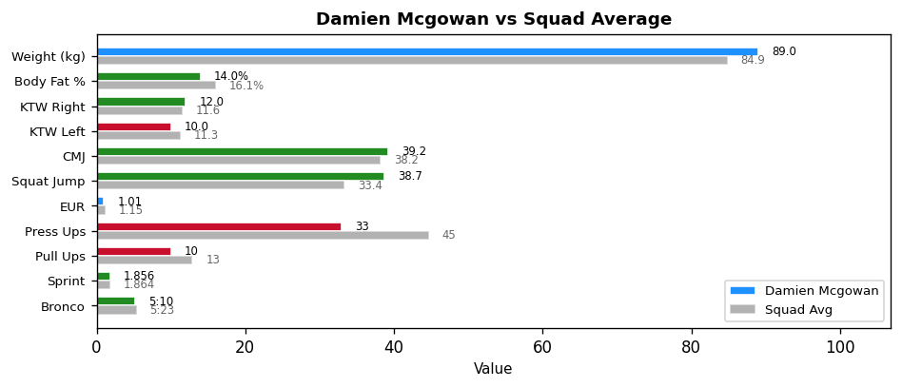

Key Focus Areas: Eccentric lifts & plyometrics (Low EUR)
Next Testing: 28th February 2026

CLG An Clochan Liath
Individual Fitness Report
3rd January 2026
Patrick O'Donnell
Weight: 67.4kg | Body Fat: 10.9% (Optimal)
Test | Your Result | Squad Avg | Status
KTW - Right (cm) | 10.0 | 11.6 | Below
KTW - Left (cm) | 12.0 | 11.3 | Above
Overhead Squat (1-3) | 2 | 2.3 | Below
CMJ (cm) | 38.7 | 38.2 | Above
Squat Jump (cm) | 30.2 | 33.4 | Below
Press Ups (60s) | 44 | 45 | Below
Pull Ups (60s) | 12 | 13 | Below
0-10m Sprint (s) | 1.887 | 1.864 | Below
Bronco Test | 5:25 | 5:23 | Below

EUR (Eccentric Utilization Ratio): 1.28 (High) | Squad Avg: 1.15
MAS (100%): 3.69 m/s | MAS (120%): 4.43 m/s | Squad Avg: 3.74 m/s
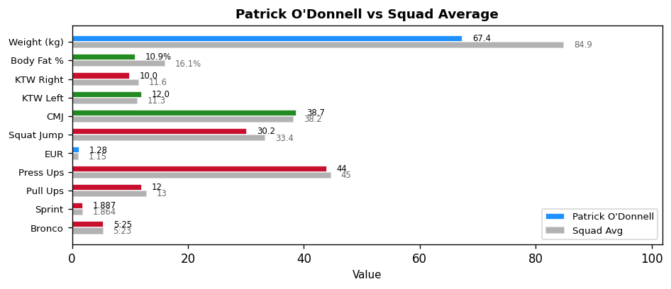

Key Focus Areas: Additional conditioning required | Maintain elasticity, build strength (High EUR)
Next Testing: 28th February 2026

CLG An Clochan Liath
Individual Fitness Report
3rd January 2026
Conor Greene
Weight: 100.2kg | Body Fat: 22.8% (Needs Attention)
Test | Your Result | Squad Avg | Status
KTW - Right (cm) | 10.0 | 11.6 | Below
KTW - Left (cm) | 12.0 | 11.3 | Above
Overhead Squat (1-3) | 3 | 2.3 | Above
CMJ (cm) | 33.9 | 38.2 | Below
Squat Jump (cm) | 25.6 | 33.4 | Below
Press Ups (60s) | 34 | 45 | Below
Pull Ups (60s) | 11 | 13 | Below
0-10m Sprint (s) | 1.939 | 1.864 | Below
Bronco Test | 5:33 | 5:23 | Below

EUR (Eccentric Utilization Ratio): 1.32 (High) | Squad Avg: 1.15
MAS (100%): 3.60 m/s | MAS (120%): 4.32 m/s | Squad Avg: 3.74 m/s
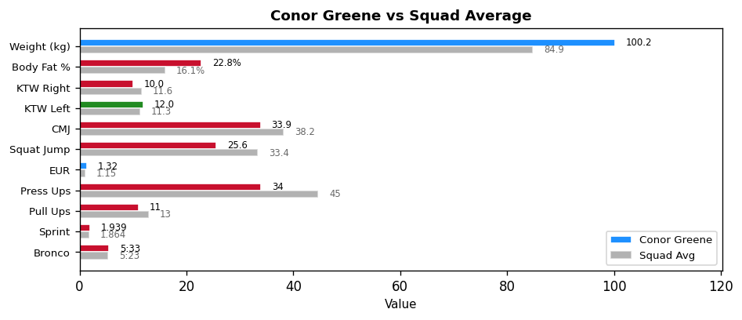

Key Focus Areas: Body composition - work with nutritionist | Additional conditioning required | Maintain elasticity, build strength (High EUR)
Next Testing: 28th February 2026

CLG An Clochan Liath
Individual Fitness Report
3rd January 2026
Daire Gallagher
Weight: 72.4kg | Body Fat: 17.3% (Acceptable)
Test | Your Result | Squad Avg | Status
KTW - Right (cm) | 14.0 | 11.6 | Above
KTW - Left (cm) | 14.0 | 11.3 | Above
Overhead Squat (1-3) | 3 | 2.3 | Above
CMJ (cm) | 36.9 | 38.2 | Below
Squat Jump (cm) | 30.0 | 33.4 | Below
Press Ups (60s) | 52 | 45 | Above
Pull Ups (60s) | 9 | 13 | Below
0-10m Sprint (s) | 1.803 | 1.864 | Above
Bronco Test | 5:20 | 5:23 | Above

EUR (Eccentric Utilization Ratio): 1.23 (High) | Squad Avg: 1.15
MAS (100%): 3.75 m/s | MAS (120%): 4.50 m/s | Squad Avg: 3.74 m/s
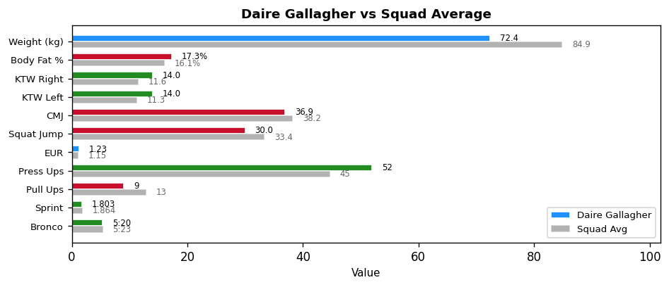

Key Focus Areas: Upper body strength | Additional conditioning required | Maintain elasticity, build strength (High EUR)
Next Testing: 28th February 2026

CLG An Clochan Liath
Individual Fitness Report
3rd January 2026
Ethan Mccaffrey
Weight: 90.2kg | Body Fat: 15.2% (Acceptable)
Test | Your Result | Squad Avg | Status
KTW - Right (cm) | 8.0 | 11.6 | Below
KTW - Left (cm) | 8.0 | 11.3 | Below
Overhead Squat (1-3) | 1 | 2.3 | Below
CMJ (cm) | 41.8 | 38.2 | Above
Squat Jump (cm) | 34.7 | 33.4 | Above
Press Ups (60s) | 37 | 45 | Below
Pull Ups (60s) | 9 | 13 | Below
0-10m Sprint (s) | 1.956 | 1.864 | Below
Bronco Test | 5:13 | 5:23 | Above

EUR (Eccentric Utilization Ratio): 1.20 (High) | Squad Avg: 1.15
MAS (100%): 3.83 m/s | MAS (120%): 4.60 m/s | Squad Avg: 3.74 m/s
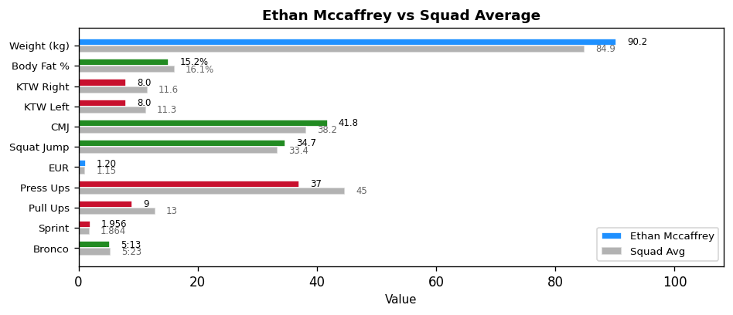

Key Focus Areas: Ankle mobility (R) | Ankle mobility (L) | Movement quality | Upper body strength | Maintain elasticity, build strength (High EUR)
Next Testing: 28th February 2026

CLG An Clochan Liath
Individual Fitness Report
3rd January 2026
Oisin Bonner
Weight: 90.6kg | Body Fat: 20.8% (Needs Attention)
Test | Your Result | Squad Avg | Status
KTW - Right (cm) | 8.0 | 11.6 | Below
KTW - Left (cm) | 8.0 | 11.3 | Below
Overhead Squat (1-3) | 2 | 2.3 | Below
CMJ (cm) | 35.3 | 38.2 | Below
Squat Jump (cm) | 31.8 | 33.4 | Below
Press Ups (60s) | INJ | 45 | INJ/DNS
Pull Ups (60s) | INJ | 13 | INJ/DNS
0-10m Sprint (s) | 1.806 | 1.864 | Above
Bronco Test | 5:18 | 5:23 | Above

EUR (Eccentric Utilization Ratio): 1.11 (Optimal) | Squad Avg: 1.15
MAS (100%): 3.77 m/s | MAS (120%): 4.53 m/s | Squad Avg: 3.74 m/s
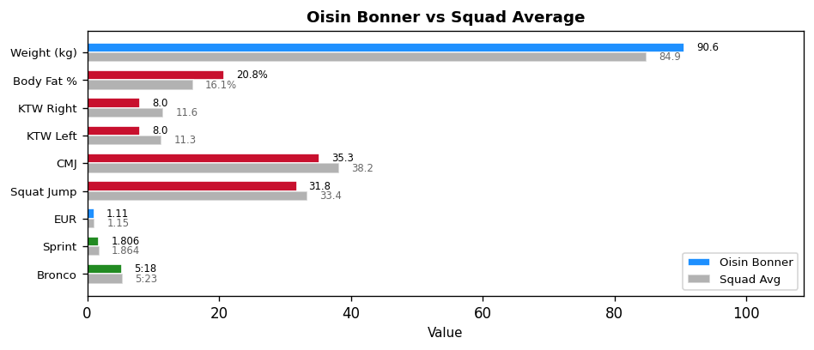

Key Focus Areas: Body composition - work with nutritionist | Ankle mobility (R) | Ankle mobility (L) | Additional conditioning required
Next Testing: 28th February 2026

CLG An Clochan Liath
Individual Fitness Report
3rd January 2026
Oran Gallagher
Weight: 92.8kg | Body Fat: 24.0% (Needs Attention)
Test | Your Result | Squad Avg | Status
KTW - Right (cm) | 8.0 | 11.6 | Below
KTW - Left (cm) | 7.0 | 11.3 | Below
Overhead Squat (1-3) | 1 | 2.3 | Below
CMJ (cm) | 30.0 | 38.2 | Below
Squat Jump (cm) | 27.2 | 33.4 | Below
Press Ups (60s) | 28 | 45 | Below
Pull Ups (60s) | 1 | 13 | Below
0-10m Sprint (s) | 1.904 | 1.864 | Below
Bronco Test | DNS | 5:23 | INJ/DNS

EUR (Eccentric Utilization Ratio): 1.10 (Optimal) | Squad Avg: 1.15
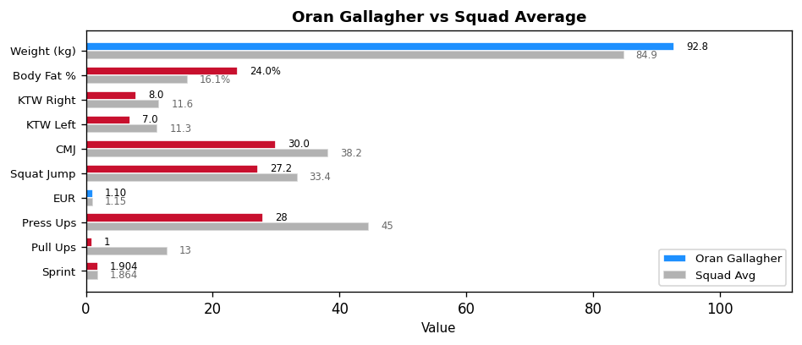

Key Focus Areas: Body composition - work with nutritionist | Ankle mobility (R) | Ankle mobility (L) | Movement quality | Upper body strength
Next Testing: 28th February 2026

CLG An Clochan Liath
Individual Fitness Report
3rd January 2026
Shaun Mcgee
Weight: 84.8kg | Body Fat: 20.1% (Needs Attention)
Test | Your Result | Squad Avg | Status
KTW - Right (cm) | 8.0 | 11.6 | Below
KTW - Left (cm) | 13.0 | 11.3 | Above
Overhead Squat (1-3) | 2 | 2.3 | Below
CMJ (cm) | INJ | 38.2 | INJ/DNS
Squat Jump (cm) | INJ | 33.4 | INJ/DNS
Press Ups (60s) | 42 | 45 | Below
Pull Ups (60s) | 9 | 13 | Below
0-10m Sprint (s) | INJ | 1.864 | INJ/DNS
Bronco Test | INJ | 5:23 | INJ/DNS

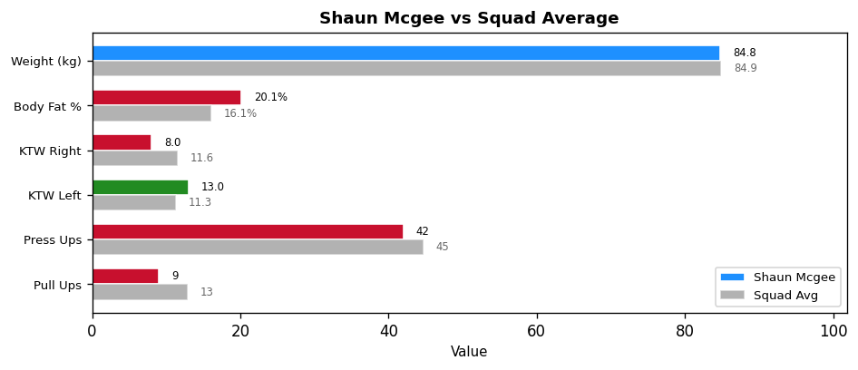

Key Focus Areas: Body composition - work with nutritionist | Ankle mobility (R) | Upper body strength
Next Testing: 28th February 2026

CLG An Clochan Liath
Individual Fitness Report
3rd January 2026
Jason Mcbride
Weight: 85.8kg | Body Fat: 12.9% (Good)
Test | Your Result | Squad Avg | Status
KTW - Right (cm) | 16.0 | 11.6 | Above
KTW - Left (cm) | 16.0 | 11.3 | Above
Overhead Squat (1-3) | 3 | 2.3 | Above
CMJ (cm) | 44.7 | 38.2 | Above
Squat Jump (cm) | 39.2 | 33.4 | Above
Press Ups (60s) | 68 | 45 | Above
Pull Ups (60s) | 17 | 13 | Above
0-10m Sprint (s) | 1.760 | 1.864 | Above
Bronco Test | 5:06 | 5:23 | Above

EUR (Eccentric Utilization Ratio): 1.14 (Optimal) | Squad Avg: 1.15
MAS (100%): 3.92 m/s | MAS (120%): 4.71 m/s | Squad Avg: 3.74 m/s
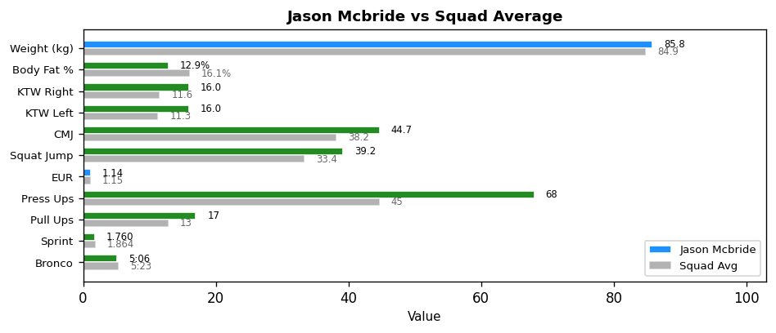

Key Focus Areas: All tests within target - maintain current programme
Next Testing: 28th February 2026

CLG An Clochan Liath
Individual Fitness Report
3rd January 2026
Ryan Grannell
Weight: 81.0kg | Body Fat: 15.3% (Acceptable)
Test | Your Result | Squad Avg | Status
KTW - Right (cm) | 14.0 | 11.6 | Above
KTW - Left (cm) | 14.0 | 11.3 | Above
Overhead Squat (1-3) | 3 | 2.3 | Above
CMJ (cm) | 32.1 | 38.2 | Below
Squat Jump (cm) | 30.9 | 33.4 | Below
Press Ups (60s) | 40 | 45 | Below
Pull Ups (60s) | 4 | 13 | Below
0-10m Sprint (s) | 1.880 | 1.864 | Below
Bronco Test | 5:17 | 5:23 | Above

EUR (Eccentric Utilization Ratio): 1.04 (Low) | Squad Avg: 1.15
MAS (100%): 3.79 m/s | MAS (120%): 4.54 m/s | Squad Avg: 3.74 m/s
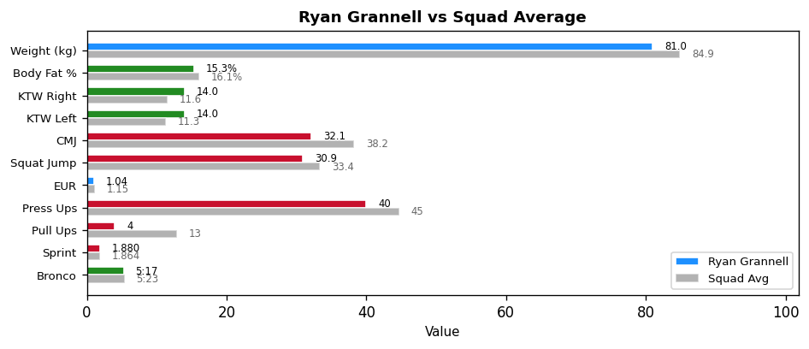

Key Focus Areas: Upper body strength | Additional conditioning required | Eccentric lifts & plyometrics (Low EUR)
Next Testing: 28th February 2026

CLG An Clochan Liath
Individual Fitness Report
3rd January 2026
Kyle Bonner
Weight: 65.2kg | Body Fat: 9.3% (Optimal)
Test | Your Result | Squad Avg | Status
KTW - Right (cm) | 12.0 | 11.6 | Above
KTW - Left (cm) | 10.0 | 11.3 | Below
Overhead Squat (1-3) | 2 | 2.3 | Below
CMJ (cm) | 39.9 | 38.2 | Above
Squat Jump (cm) | 32.5 | 33.4 | Below
Press Ups (60s) | 37 | 45 | Below
Pull Ups (60s) | 16 | 13 | Above
0-10m Sprint (s) | 1.826 | 1.864 | Above
Bronco Test | 5:14 | 5:23 | Above

EUR (Eccentric Utilization Ratio): 1.23 (High) | Squad Avg: 1.15
MAS (100%): 3.82 m/s | MAS (120%): 4.59 m/s | Squad Avg: 3.74 m/s
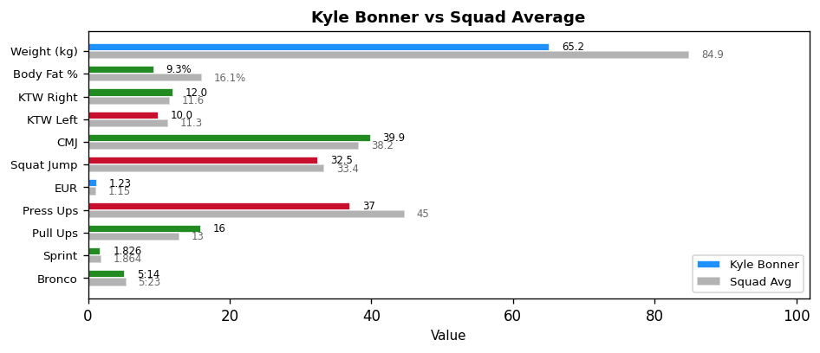

Key Focus Areas: Maintain elasticity, build strength (High EUR)
Next Testing: 28th February 2026

CLG An Clochan Liath
Individual Fitness Report
3rd January 2026
Killian Gillespie
Weight: 81.6kg | Body Fat: 15.2% (Acceptable)
Test | Your Result | Squad Avg | Status
KTW - Right (cm) | 14.0 | 11.6 | Above
KTW - Left (cm) | 14.0 | 11.3 | Above
Overhead Squat (1-3) | 2 | 2.3 | Below
CMJ (cm) | 42.2 | 38.2 | Above
Squat Jump (cm) | 32.5 | 33.4 | Below
Press Ups (60s) | 39 | 45 | Below
Pull Ups (60s) | 9 | 13 | Below
0-10m Sprint (s) | 1.790 | 1.864 | Above
Bronco Test | 5:03 | 5:23 | Above

EUR (Eccentric Utilization Ratio): 1.30 (High) | Squad Avg: 1.15
MAS (100%): 3.96 m/s | MAS (120%): 4.75 m/s | Squad Avg: 3.74 m/s
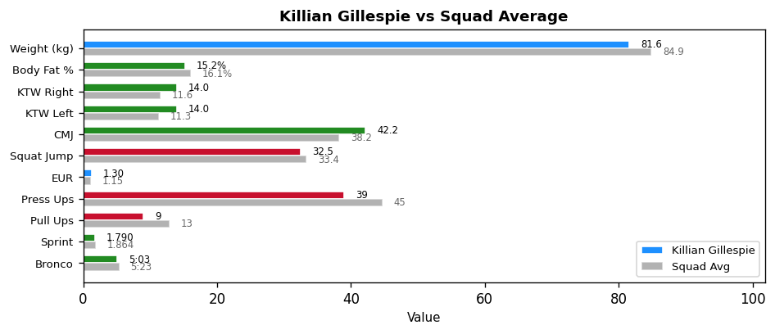

Key Focus Areas: Upper body strength | Maintain elasticity, build strength (High EUR)
Next Testing: 28th February 2026

CLG An Clochan Liath
Individual Fitness Report
3rd January 2026
Cianan Mcdaid
Weight: 76.6kg | Body Fat: 12.5% (Good)
Test | Your Result | Squad Avg | Status
KTW - Right (cm) | 10.0 | 11.6 | Below
KTW - Left (cm) | 9.0 | 11.3 | Below
Overhead Squat (1-3) | 2 | 2.3 | Below
CMJ (cm) | 40.8 | 38.2 | Above
Squat Jump (cm) | 40.4 | 33.4 | Above
Press Ups (60s) | 45 | 45 | Above
Pull Ups (60s) | 14 | 13 | Above
0-10m Sprint (s) | 1.802 | 1.864 | Above
Bronco Test | 4:53 | 5:23 | Above

EUR (Eccentric Utilization Ratio): 1.01 (Low) | Squad Avg: 1.15
MAS (100%): 4.10 m/s | MAS (120%): 4.91 m/s | Squad Avg: 3.74 m/s
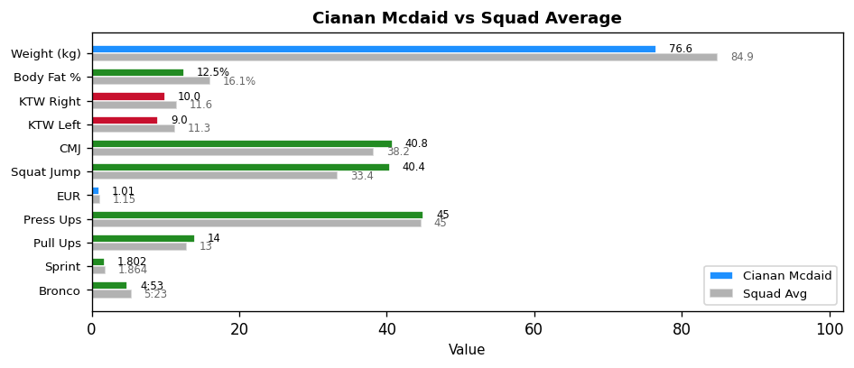

Key Focus Areas: Ankle mobility (L) | Eccentric lifts & plyometrics (Low EUR)
Next Testing: 28th February 2026

CLG An Clochan Liath
Individual Fitness Report
3rd January 2026
Danny Rodgers
Weight: 108.6kg | Body Fat: 17.0% (Acceptable)
Test | Your Result | Squad Avg | Status
KTW - Right (cm) | 14.0 | 11.6 | Above
KTW - Left (cm) | 12.0 | 11.3 | Above
Overhead Squat (1-3) | 3 | 2.3 | Above
CMJ (cm) | 45.6 | 38.2 | Above
Squat Jump (cm) | 38.9 | 33.4 | Above
Press Ups (60s) | 56 | 45 | Above
Pull Ups (60s) | 27 | 13 | Above
0-10m Sprint (s) | 1.909 | 1.864 | Below
Bronco Test | 5:40 | 5:23 | Below

EUR (Eccentric Utilization Ratio): 1.17 (Optimal) | Squad Avg: 1.15
MAS (100%): 3.53 m/s | MAS (120%): 4.24 m/s | Squad Avg: 3.74 m/s
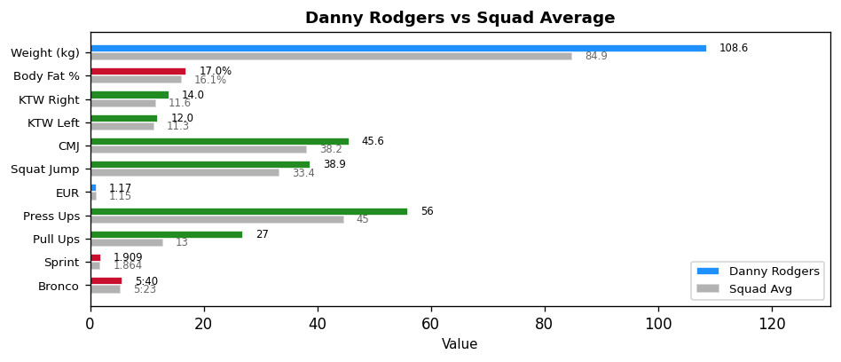

Key Focus Areas: Additional conditioning required
Next Testing: 28th February 2026

CLG An Clochan Liath
Individual Fitness Report
3rd January 2026
Barry Curran
Weight: 85.0kg | Body Fat: 16.3% (Acceptable)
Test | Your Result | Squad Avg | Status
KTW - Right (cm) | 16.0 | 11.6 | Above
KTW - Left (cm) | 16.0 | 11.3 | Above
Overhead Squat (1-3) | 3 | 2.3 | Above
CMJ (cm) | 42.3 | 38.2 | Above
Squat Jump (cm) | 35.3 | 33.4 | Above
Press Ups (60s) | 65 | 45 | Above
Pull Ups (60s) | 19 | 13 | Above
0-10m Sprint (s) | 1.748 | 1.864 | Above
Bronco Test | 5:01 | 5:23 | Above

EUR (Eccentric Utilization Ratio): 1.20 (Optimal) | Squad Avg: 1.15
MAS (100%): 3.99 m/s | MAS (120%): 4.78 m/s | Squad Avg: 3.74 m/s
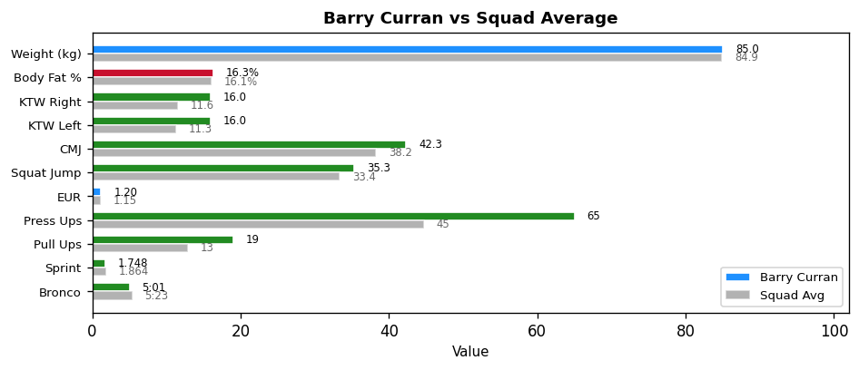

Key Focus Areas: All tests within target - maintain current programme
Next Testing: 28th February 2026

CLG An Clochan Liath
Individual Fitness Report
3rd January 2026
Daniel Ward
Weight: 89.2kg | Body Fat: 13.8% (Good)
Test | Your Result | Squad Avg | Status
KTW - Right (cm) | 8.0 | 11.6 | Below
KTW - Left (cm) | 2.0 | 11.3 | Below
Overhead Squat (1-3) | 2 | 2.3 | Below
CMJ (cm) | 31.0 | 38.2 | Below
Squat Jump (cm) | 31.4 | 33.4 | Below
Press Ups (60s) | 43 | 45 | Below
Pull Ups (60s) | 16 | 13 | Above
0-10m Sprint (s) | 1.894 | 1.864 | Below
Bronco Test | 5:38 | 5:23 | Below

EUR (Eccentric Utilization Ratio): 0.99 (Low) | Squad Avg: 1.15
MAS (100%): 3.55 m/s | MAS (120%): 4.26 m/s | Squad Avg: 3.74 m/s
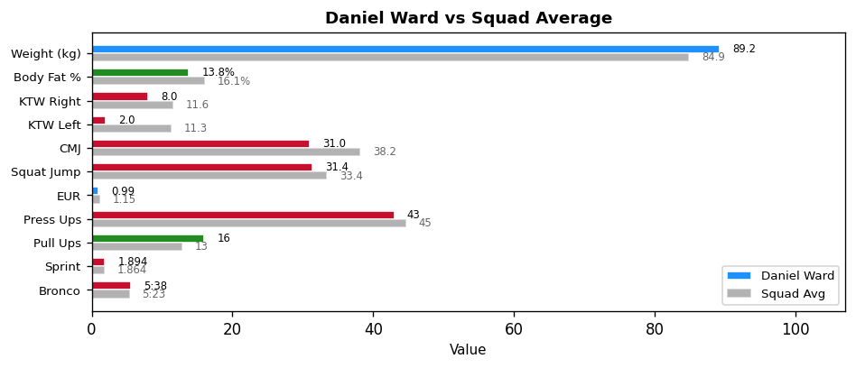

Key Focus Areas: Ankle mobility (R) | Ankle mobility (L) | Additional conditioning required | Eccentric lifts & plyometrics (Low EUR)
Next Testing: 28th February 2026

CLG An Clochan Liath
Individual Fitness Report
3rd January 2026
Matthew Ward
Weight: 94.6kg | Body Fat: 16.8% (Acceptable)
Test | Your Result | Squad Avg | Status
KTW - Right (cm) | 9.0 | 11.6 | Below
KTW - Left (cm) | 10.0 | 11.3 | Below
Overhead Squat (1-3) | 3 | 2.3 | Above
CMJ (cm) | 40.8 | 38.2 | Above
Squat Jump (cm) | 35.0 | 33.4 | Above
Press Ups (60s) | 48 | 45 | Above
Pull Ups (60s) | 17 | 13 | Above
0-10m Sprint (s) | 1.887 | 1.864 | Below
Bronco Test | 5:37 | 5:23 | Below

EUR (Eccentric Utilization Ratio): 1.16 (Optimal) | Squad Avg: 1.15
MAS (100%): 3.56 m/s | MAS (120%): 4.27 m/s | Squad Avg: 3.74 m/s
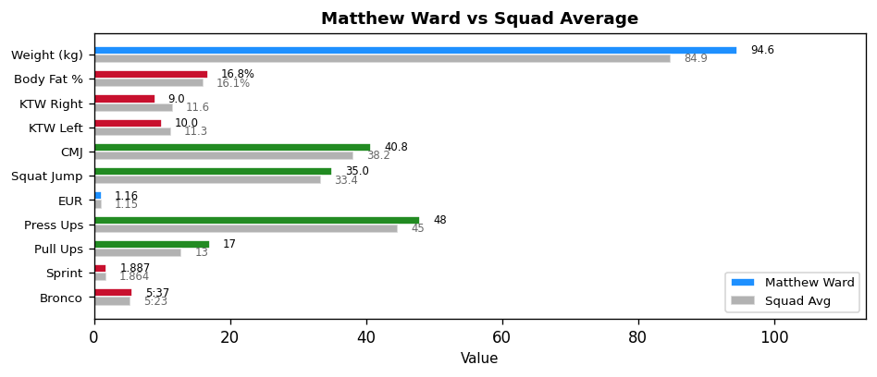

Key Focus Areas: Ankle mobility (R) | Additional conditioning required
Next Testing: 28th February 2026

CLG An Clochan Liath
Individual Fitness Report
3rd January 2026
Danny Mccready
Weight: 61.0kg | Body Fat: 8.9% (Optimal)
Test | Your Result | Squad Avg | Status
KTW - Right (cm) | 11.0 | 11.6 | Below
KTW - Left (cm) | 11.0 | 11.3 | Below
Overhead Squat (1-3) | 3 | 2.3 | Above
CMJ (cm) | 39.5 | 38.2 | Above
Squat Jump (cm) | 38.0 | 33.4 | Above
Press Ups (60s) | 45 | 45 | Above
Pull Ups (60s) | 16 | 13 | Above
0-10m Sprint (s) | 1.738 | 1.864 | Above
Bronco Test | 4:54 | 5:23 | Above

EUR (Eccentric Utilization Ratio): 1.04 (Low) | Squad Avg: 1.15
MAS (100%): 4.08 m/s | MAS (120%): 4.90 m/s | Squad Avg: 3.74 m/s
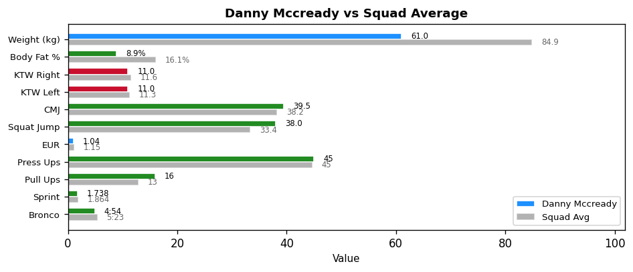

Key Focus Areas: Eccentric lifts & plyometrics (Low EUR)
Next Testing: 28th February 2026

CLG An Clochan Liath
Individual Fitness Report
3rd January 2026
Joe Neely
Weight: 77.6kg | Body Fat: 21.2% (Needs Attention)
Test | Your Result | Squad Avg | Status
KTW - Right (cm) | 11.0 | 11.6 | Below
KTW - Left (cm) | 10.0 | 11.3 | Below
Overhead Squat (1-3) | 2 | 2.3 | Above
CMJ (cm) | 32.4 | 38.2 | Below
Squat Jump (cm) | 36.7 | 33.4 | Above
Press Ups (60s) | 53 | 45 | Above
Pull Ups (60s) | 8 | 13 | Below
0-10m Sprint (s) | 1.865 | 1.864 | Below
Bronco Test | 7:20 | 5:23 | Below

EUR (Eccentric Utilization Ratio): 0.88 (Low) | Squad Avg: 1.15
MAS (100%): 2.73 m/s | MAS (120%): 3.27 m/s | Squad Avg: 3.74 m/s
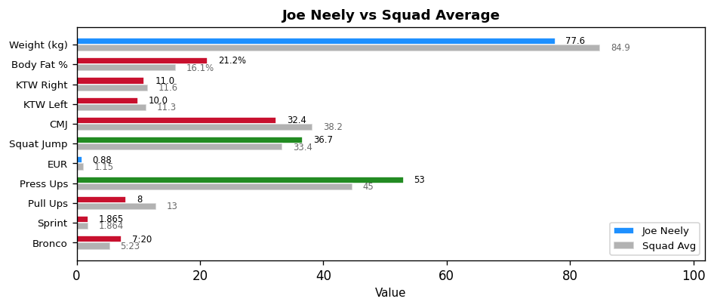

Key Focus Areas: Body composition - work with nutritionist | Upper body strength | Additional conditioning required | Eccentric lifts & plyometrics (Low EUR)
Next Testing: 28th February 2026

CLG An Clochan Liath
Individual Fitness Report
3rd January 2026
Paddy Bonner
Weight: 85.0kg | Body Fat: 20.6% (Needs Attention)
Test | Your Result | Squad Avg | Status
KTW - Right (cm) | 12.0 | 11.6 | Above
KTW - Left (cm) | N/A | 11.3 | -
Overhead Squat (1-3) | 3 | 2.3 | Above
CMJ (cm) | INJ | 38.2 | INJ/DNS
Squat Jump (cm) | INJ | 33.4 | INJ/DNS
Press Ups (60s) | 49 | 45 | Above
Pull Ups (60s) | 4 | 13 | Below
0-10m Sprint (s) | INJ | 1.864 | INJ/DNS
Bronco Test | INJ | 5:23 | INJ/DNS

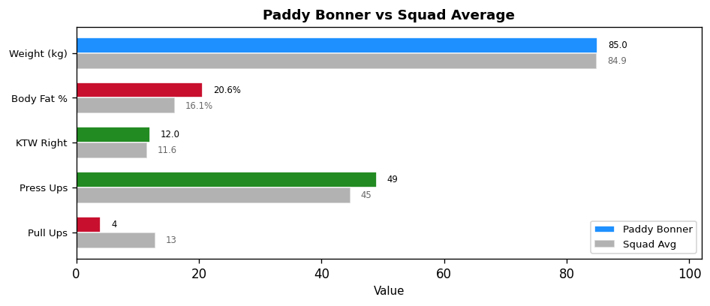

Key Focus Areas: Body composition - work with nutritionist | Upper body strength
Next Testing: 28th February 2026

CLG An Clochan Liath
Individual Fitness Report
3rd January 2026
Conor O'Donnell
Weight: 89.4kg | Body Fat: 16.5% (Acceptable)
Test | Your Result | Squad Avg | Status
KTW - Right (cm) | 12.0 | 11.6 | Above
KTW - Left (cm) | 12.0 | 11.3 | Above
Overhead Squat (1-3) | 3 | 2.3 | Above
CMJ (cm) | 40.9 | 38.2 | Above
Squat Jump (cm) | 35.6 | 33.4 | Above
Press Ups (60s) | 59 | 45 | Above
Pull Ups (60s) | 18 | 13 | Above
0-10m Sprint (s) | 1.856 | 1.864 | Above
Bronco Test | 4:58 | 5:23 | Above

EUR (Eccentric Utilization Ratio): 1.15 (Optimal) | Squad Avg: 1.15
MAS (100%): 4.03 m/s | MAS (120%): 4.83 m/s | Squad Avg: 3.74 m/s
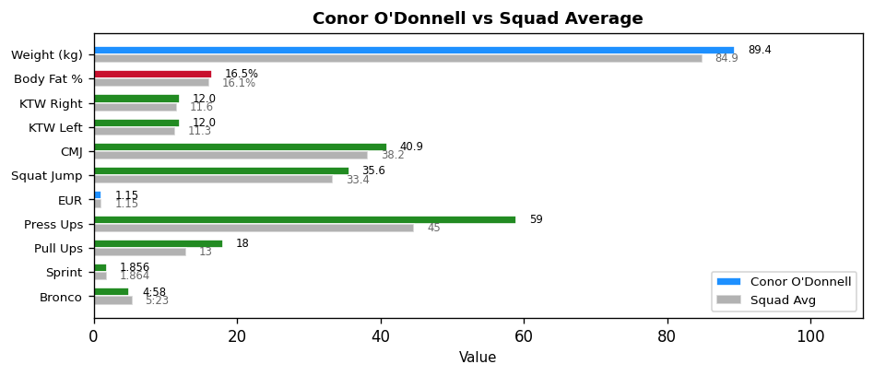

Key Focus Areas: All tests within target - maintain current programme
Next Testing: 28th February 2026

CLG An Clochan Liath
Individual Fitness Report
3rd January 2026
Cian Gallagher
Weight: 80.0kg | Body Fat: 15.4% (Acceptable)
Test | Your Result | Squad Avg | Status
KTW - Right (cm) | 14.0 | 11.6 | Above
KTW - Left (cm) | 10.0 | 11.3 | Below
Overhead Squat (1-3) | 2 | 2.3 | Below
CMJ (cm) | 28.1 | 38.2 | Below
Squat Jump (cm) | 22.9 | 33.4 | Below
Press Ups (60s) | 45 | 45 | Above
Pull Ups (60s) | 11 | 13 | Below
0-10m Sprint (s) | 1.943 | 1.864 | Below
Bronco Test | 5:33 | 5:23 | Below

EUR (Eccentric Utilization Ratio): 1.23 (High) | Squad Avg: 1.15
MAS (100%): 3.60 m/s | MAS (120%): 4.32 m/s | Squad Avg: 3.74 m/s
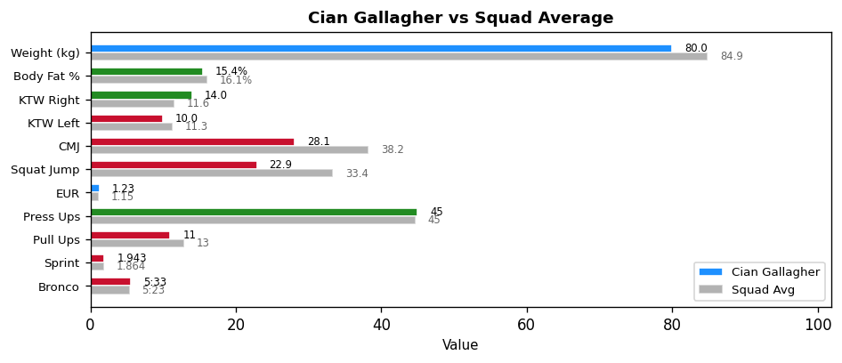

Key Focus Areas: Additional conditioning required | Maintain elasticity, build strength (High EUR)
Next Testing: 28th February 2026

CLG An Clochan Liath
Individual Fitness Report
3rd January 2026
Jamie Mccready
Weight: 69.2kg | Body Fat: 11.2% (Optimal)
Test | Your Result | Squad Avg | Status
KTW - Right (cm) | 14.0 | 11.6 | Above
KTW - Left (cm) | 14.0 | 11.3 | Above
Overhead Squat (1-3) | 2 | 2.3 | Below
CMJ (cm) | 41.9 | 38.2 | Above
Squat Jump (cm) | 32.6 | 33.4 | Below
Press Ups (60s) | 32 | 45 | Below
Pull Ups (60s) | 13 | 13 | Above
0-10m Sprint (s) | 1.905 | 1.864 | Below
Bronco Test | 5:27 | 5:23 | Below

EUR (Eccentric Utilization Ratio): 1.29 (High) | Squad Avg: 1.15
MAS (100%): 3.67 m/s | MAS (120%): 4.40 m/s | Squad Avg: 3.74 m/s
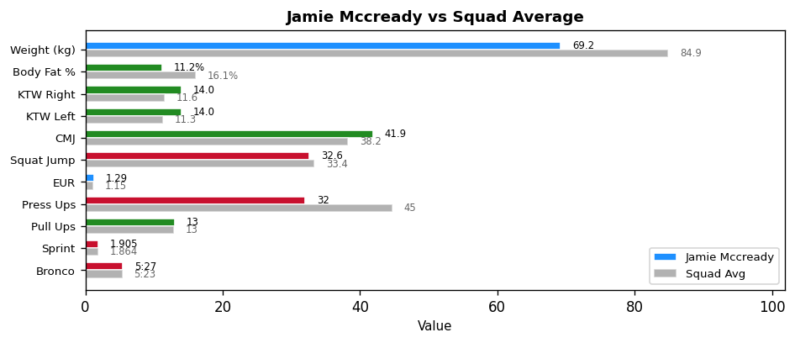

Key Focus Areas: Additional conditioning required | Maintain elasticity, build strength (High EUR)
Next Testing: 28th February 2026

CLG An Clochan Liath
Individual Fitness Report
3rd January 2026
Joe Mcelroy
Weight: 79.2kg | Body Fat: 14.8% (Good)
Test | Your Result | Squad Avg | Status
KTW - Right (cm) | 10.0 | 11.6 | Below
KTW - Left (cm) | 10.0 | 11.3 | Below
Overhead Squat (1-3) | 2 | 2.3 | Below
CMJ (cm) | 33.9 | 38.2 | Below
Squat Jump (cm) | 28.1 | 33.4 | Below
Press Ups (60s) | 36 | 45 | Below
Pull Ups (60s) | 9 | 13 | Below
0-10m Sprint (s) | 1.990 | 1.864 | Below
Bronco Test | DNF | 5:23 | INJ/DNS

EUR (Eccentric Utilization Ratio): 1.21 (High) | Squad Avg: 1.15
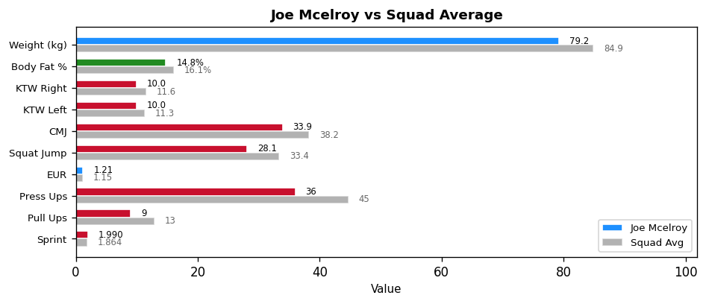

Key Focus Areas: Upper body strength | Maintain elasticity, build strength (High EUR)
Next Testing: 28th February 2026

CLG An Clochan Liath
Individual Fitness Report
3rd January 2026
Dylan O'Donnell
Weight: 89.2kg | Body Fat: 15.8% (Acceptable)
Test | Your Result | Squad Avg | Status
KTW - Right (cm) | 12.0 | 11.6 | Above
KTW - Left (cm) | 14.0 | 11.3 | Above
Overhead Squat (1-3) | 2 | 2.3 | Below
CMJ (cm) | 36.9 | 38.2 | Below
Squat Jump (cm) | 33.6 | 33.4 | Above
Press Ups (60s) | 25 | 45 | Below
Pull Ups (60s) | 11 | 13 | Below
0-10m Sprint (s) | 1.784 | 1.864 | Above
Bronco Test | 5:24 | 5:23 | Below

EUR (Eccentric Utilization Ratio): 1.10 (Low) | Squad Avg: 1.15
MAS (100%): 3.70 m/s | MAS (120%): 4.44 m/s | Squad Avg: 3.74 m/s
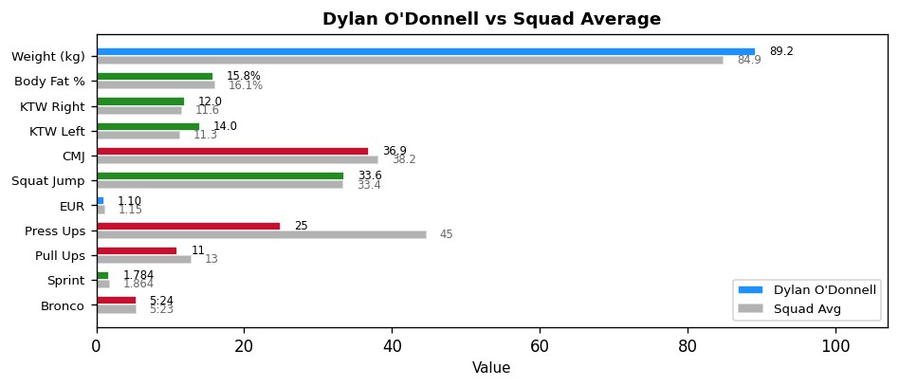

Key Focus Areas: Additional conditioning required | Eccentric lifts & plyometrics (Low EUR)
Next Testing: 28th February 2026

CLG An Clochan Liath
Individual Fitness Report
3rd January 2026
Eoin Doogan
Weight: 134.6kg | Body Fat: 30.1% (Needs Attention)
Test | Your Result | Squad Avg | Status
KTW - Right (cm) | 14.0 | 11.6 | Above
KTW - Left (cm) | 14.0 | 11.3 | Above
Overhead Squat (1-3) | 2 | 2.3 | Below
CMJ (cm) | 31.8 | 38.2 | Below
Squat Jump (cm) | 27.6 | 33.4 | Below
Press Ups (60s) | 28 | 45 | Below
Pull Ups (60s) | 7 | 13 | Below
0-10m Sprint (s) | 2.041 | 1.864 | Below
Bronco Test | 7:03 | 5:23 | Below

EUR (Eccentric Utilization Ratio): 1.15 (Optimal) | Squad Avg: 1.15
MAS (100%): 2.84 m/s | MAS (120%): 3.40 m/s | Squad Avg: 3.74 m/s
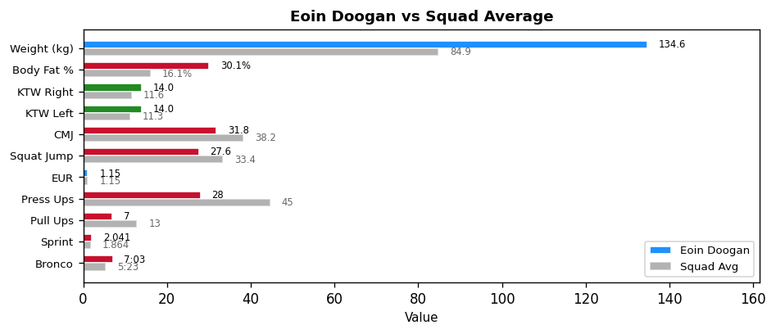

Key Focus Areas: Body composition - work with nutritionist | Upper body strength | Additional conditioning required
Next Testing: 28th February 2026

